Chapter 4: Toolpath generation
  - Breakdown of the program
The programming language Python is used to develop the CAM system for the toolpath generation because it was mentioned in the previous chapter. The CAM system below is based on previous research’s CAM system, however, adjusted for more complex shapes rather than just a truncated cone. The following code is divided into four simple sections, which will be explained in the following sections.
The general flow of the program goes like this. Import the STL data from the design software-> setup of the variables, libraries, and tool path logic -> toolpath generation and g-code conversion-> compiling and finishing touches, and can be shown in the figure below.

Figure 4.1: General outline of CAM program

# Importing libraries that will be used for the rest of the code
import pyvista as pv
import csv
import pandas as pd
import numpy as np
from scipy.spatial import ConvexHull
from scipy.spatial.distance import pdist, squareform
from scipy.optimize import linear_sum_assignment

mesh = pv.read('freeform_test_17.stl') # Load the STL to form the point cloud
mesh = mesh.subdivide(2) # Increase this number (e.g., 3 or 4) for more points
points = mesh.points # Turing the point cloud to the mesh into points for processing

pd.options.mode.copy_on_write = True # Only copies the relevent points when needed for the entire program

with open('dots.csv', 'w') as f: #Saving the mesh points
csv.writer(f).writerows(points) # Sorts the points by Z coordinates
df = pd.read_csv('dots.csv', header=None, names=['x', 'y', 'z']).dropna() # Puts the sorted points into dots.csv

df = df[df['z'] > df['z'].min() + 0.1] # This is removes the bottom layer of the shape to prevent the machine reprocessing points

layer_spacing = 0.2 # Set the distance between layers (in your desired units)
Figure 4.2: Variables and library setup

# Module for ensuring line spacing
def enforce_layer_spacing(df, layer_spacing):
z_min = df['z'].min()
layers = np.arange(z_min, df['z'].max() + layer_spacing, layer_spacing) # Compute possible layer positions based on layer spacing
df['z'] = layers[np.argmin(np.abs(df['z'].values[:, None] - layers), axis=1)] # Assign each point to the closest layer
return df
df = enforce_layer_spacing(df, layer_spacing)

# Module for calculating the circular shapes
def is_circular_shape(points, tolerance=0.1): # The tolerance must be adjusted according to the dimensions of the model, the bigger the number the less amount of points are selected
center = points.mean(axis=0)
distances = np.linalg.norm(points - center, axis=1)
return np.abs(distances - distances.mean()).max() < tolerance

# Module for calculating TSP (Traveling Sales Person)
def solve_tsp(points):
distance_matrix = squareform(pdist(points))
_, col_ind = linear_sum_assignment(distance_matrix)
return col_ind

# Module for sorting the points in a clockwise direction
def sort_clockwise(points):
center = points.mean(axis=0)
angles = np.arctan2(points[:, 1] - center[1], points[:, 0] - center[0])
return points[np.argsort(angles)]

# Module for processing circular layers
def process_circular_layer(layer_points):
return sort_clockwise(layer_points)

# Module for processing non-circular layers
def process_non_circular_layer(layer_points):
tsp_order = solve_tsp(layer_points)
return sort_clockwise(layer_points[tsp_order])
Figure 4.3: Setting up logic for the tool path generation

# Initialize toolpath
ll = []
prev_exit_point = None

while len(df) > 0:
# This identifys the current layer and identifies the greatest Z coordinate or highest layer.
current_layer_z = df['z'].max()
current_layer = df[df['z'] == current_layer_z]

# This layer skips any layers with fewer than 3 points because ConvexHull is unable to process layers with less than 3 points. This stops the program from breaking.
if len(current_layer) < 3:
df = df[df['z'] < current_layer_z]
continue

# Filter points to retain only boundary points using ConvexHull. This ensures that only the outermost points are processed and saved to the tool path.
layer_points = current_layer[['x', 'y']].values
hull = ConvexHull(layer_points)
hull_coords = layer_points[hull.vertices]

# Determine if the shape is circular or non-circular
if is_circular_shape(hull_coords):
sorted_points = process_circular_layer(hull_coords)
else:
sorted_points = process_non_circular_layer(hull_coords)

# Closest point from previous layer to start
if prev_exit_point is not None:
dists = np.linalg.norm(sorted_points - prev_exit_point[:2], axis=1)
start_idx = np.argmin(dists)
sorted_points = np.roll(sorted_points, -start_idx, axis=0)

# Add Z-coordinate to sorted points
sorted_layer = np.hstack([sorted_points, np.full((sorted_points.shape[0], 1), current_layer_z)])

# This part of the code makes the tool path return to the first point of the layer and then adds this movement to the end of the tool path.
layer_path = list(sorted_layer)
layer_path.append(layer_path[0]) # Return to the first point
ll.extend(layer_path)

prev_exit_point = layer_path[0] # For continuous connection

# Remove processed points from the main DataFrame then from here it repeats untill all of the layers are processed
df = df[df['z'] < current_layer_z]

#prints the layer spacings so that we can ensure that the layers are the same distance apart from each other
unique_z = np.sort(df['z'].unique())
print("Layer spacings:", np.diff(unique_z))

# Save toolpath to a CSV
ll = np.round(ll, 3)
pd.DataFrame(ll, columns=['x', 'y', 'z']).to_csv('toolpath.csv', index=False)
Figure 4.4: Tool path generation

# Convert to G-code and save as a text file. (Can be changed to CSV or any file type.)
df_ltp = pd.read_csv('toolpath.csv')
df_gchord = pd.DataFrame({
'G': 'G01',
'x': 'X' + df_ltp['x'].astype(str),
'y': 'Y' + df_ltp['y'].astype(str),
'z': 'Z' + df_ltp['z'].astype(str),
'EOB': ';'
})

# Define the starting and ending G-code lines.
# The coordinates for the following sections (gcode_header and gcode_footer) can be changed depending on the size of the work area for the CNC machine
gcode_header = [
"G90 ; (Absolute positioning)",
"G21 ; (Set units to millimeters)",
"G92 X0.0 Y0.0 Z0 ; (Set workplace origin)",
"F1000 ; (Set feedrate)",
"G01 X0.0 Y0.0 Z20 ; (Move to safe height)"
]
# Note that for the line "G01 X0.0 Y0.0 Z20" and "G01 Z20" the Z coordinate MUST be changed depending on the work areas height.
# So that the tool goes down instead of going up from the work area origin

gcode_footer = [
"G01 Z20 ; (Retract tool)",
"M30 ; (End of program)"
]

# Add the header, G-code, and footer to the file
with open('Gchord.txt', 'w') as f:
# Write the header
for line in gcode_header:
f.write(line + '\n')

# Write the G-code toolpath
df_gchord.to_csv(f, index=False, sep=" ", header=False, mode='a')

# Write the footer
for line in gcode_footer:
f.write(line + '\n')
Figure 4.5: Initial machining and termination code with exporting the toolpath to text file.

  - Variables
A few variables are required for an accurate depiction and overall consistency of the tool path. The most important ones are mesh subdivisions, layer spacing, and tolerance. Mesh subdivisions divide each layer into parts so that more points are added to the tool path, giving a smoother tool path and making it less likely to have any problems. The layer spacing variable ensures that all the layers in the toolpath are the same distance apart. For example, layer one and layer two will have a 0.2 distance, and layer 10 and layer 11. The tolerance variable for the toolpath is a redundant measure to ensure that the toolpath does not have any issues when generating a circular shape vs. a shape with edges.

  - Modules
The “modules” or toolpath logic are groups of code that smooth out the processing of the tool path. If they were to be added to the toolpath generation logic seen in Figure X, the process of generating a toolpath would take a significantly larger amount of time. Things like TSP, which will be explained in the next section, and Clockwise processing are just some of the modules in the code.

  - TSP (Traveling Salesperson)
The most important module of the CAM system is the TSP logic. While the code in Figure 4.4 is also very important, the TSP logic ensures that the tool path will not double back on itself and create problems. The TSP logic does this by calculating the distances between the current point it is at and the points on the layer. After it does this, it will move the tool to the shortest distance point and repeat the process until all the points are reached. Something similar to the TSP logic was present in the previous researcher's research; however, it was adjusted so that other modules could be used to further optimize the code.

  - Processing loop overview
The process of toolpath generation involves several simple steps. First, the logic creates a variable so that the entire toolpath can be stored and later saved to a text file. Next, the toolpath generation will identify the highest Z coordinate or the highest layer of the figure, then eliminate any layers that have fewer than 3 points, as the module Convexhull, a module that selects the outermost points of a layer, cannot process layers that have fewer than 3 points. Then the Convexhull module selects the outermost points of the layer, and then the circular and noncircular processing modules are used to determine which type of processing to use. This redundant measure is here to ensure that nothing goes wrong with the TSP logic. The final part of the toolpath generation is moving to the next layer. The toolpath generation looks for the closest point on the next layer and saves that so the tool can return to that point later when it needs to move to the next layer. This creates a general area where the toolpath generation will always move to the next layer, cleaning up the toolpath visually. This will then repeat for the number of layers in the STL file.

  - General G-code addons
For the last section of the code, the general processing settings like spindle speed, setting the machine to absolute positioning, and setting the workplace origin are added to the beginning and end of the code so that the toolpath is ready to be put into the CNC machine right after the program is finished generating the G-code. These are found in the header and footer sections of the code and were explained in an earlier section.
The final part of the code, shown in Figure 4.5, is just to save the toolpath that was generated into a text file that can be directly put into the CNC machine.

  - NC viewer confirmation
After the CAM system generates the toolpath, to ensure that there are no issues with the toolpath, the NC viewer, an online website that can visualize the G-code, was used to ensure that there were no issues. The NC viewer is also a simulation of what will happen in the incremental forming process and can be edited as needed.
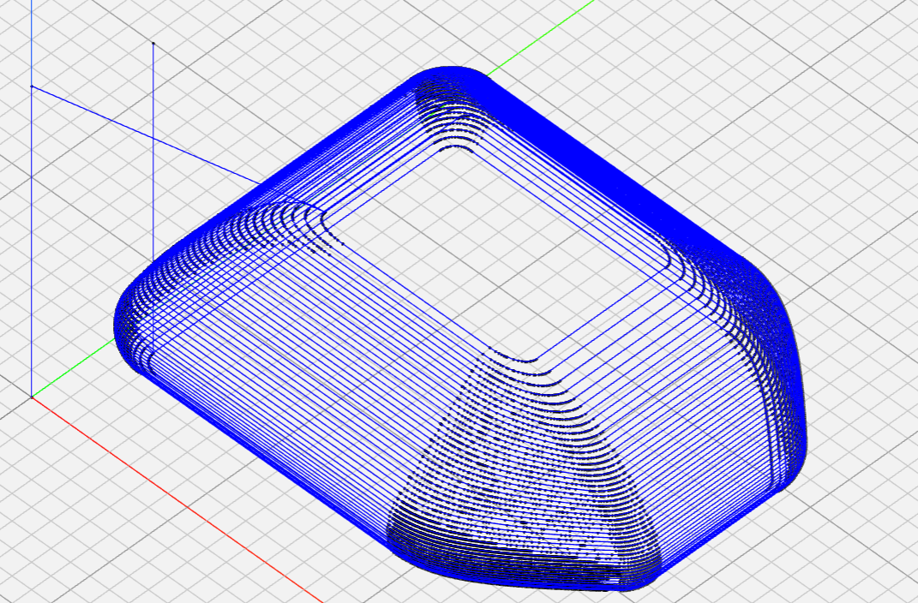
Figure 4.4. NC viewer confirmation of the toolpath.

